**IDB Lab2**

1. select * from dept;

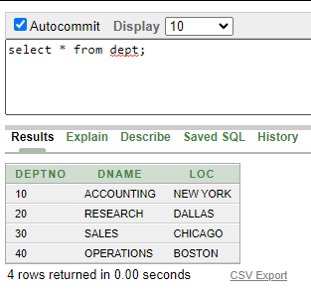

1. select deptno, dname from dept;

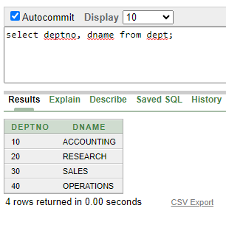

1. select EMPNO, ENAME, SAL, SAL+1000 from emp;

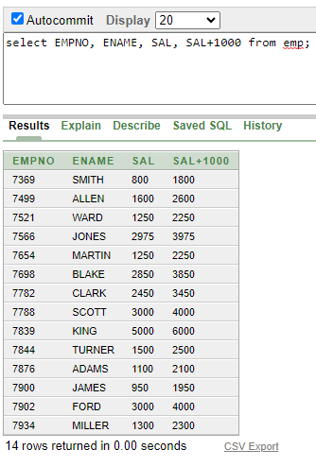

1. select EMPNO, ENAME, SAL, 10*SAL+1000 from emp;

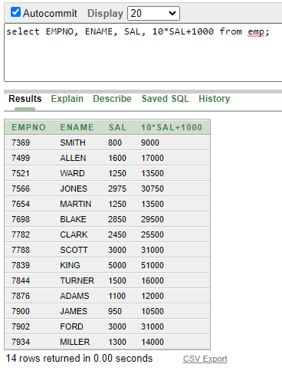

1. select EMPNO, ENAME, SAL, 10*(SAL+1000) from emp;

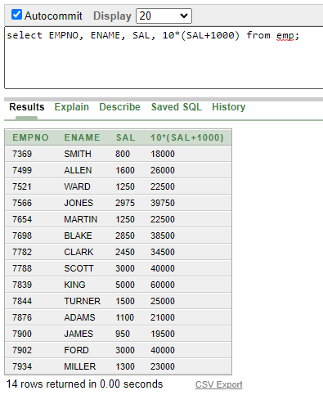

1. select EMPNO, ENAME, comm from emp;

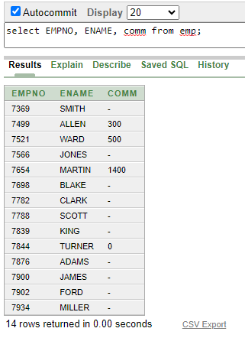

1. select EMPNO, ENAME, 10*sal+comm from emp WHERE ENAME = 'KING';

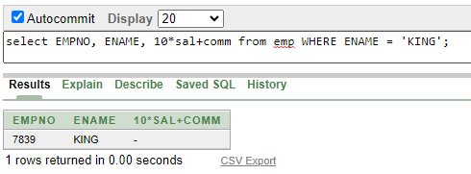

1. select EMPNO as id, ENAME as name, sal as salary from emp;

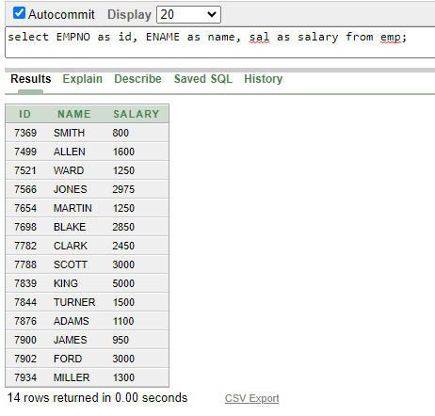

1. select EMPNO "id", ENAME "name", sal "salary" from emp;

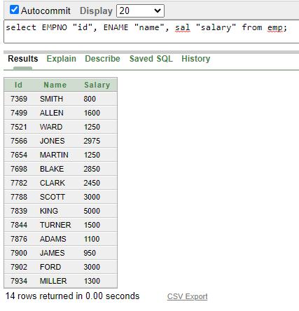

1. select EMPNO "id", ENAME "name", 12*sal "Annual salary" from emp;

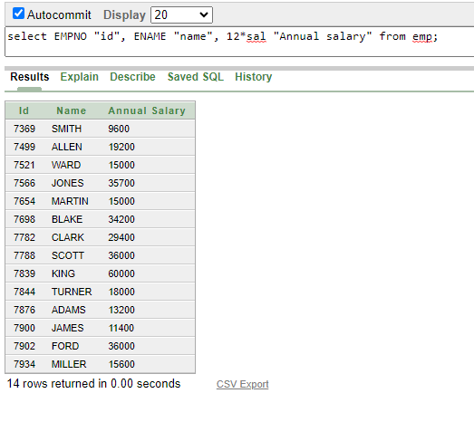

1. select ENAME || JOB as "Employees" from emp;

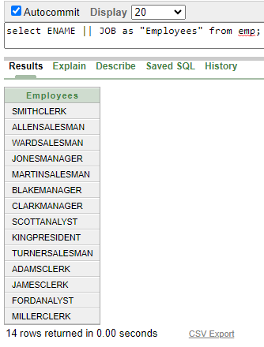

1. select ENAME || ' ' || 'is a ' || JOB as "Employees Details" from emp;

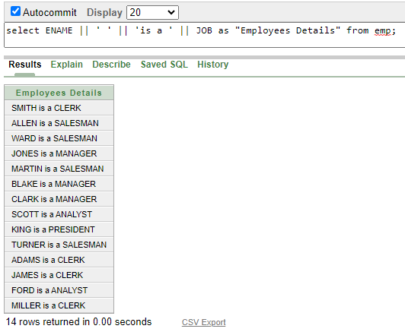

1. select deptno from emp;

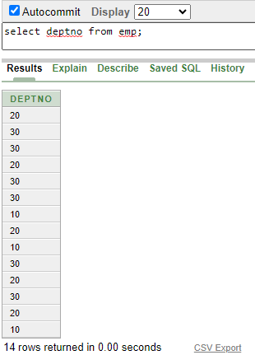

1. select DISTINCT deptno from emp;

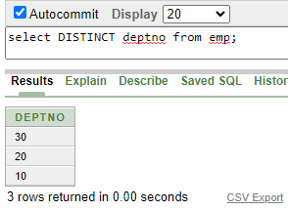

1. DESCRIBE dept

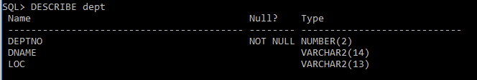

**Lab Task: 01**

1. select ENAME "Name", DEPTNO "Department Number" from emp;

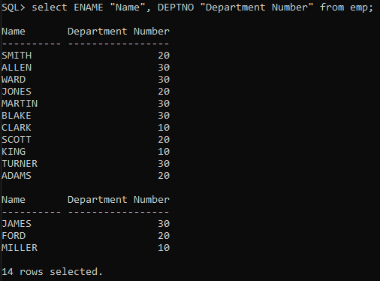

1. select JOB from emp where DEPTNO = '30';

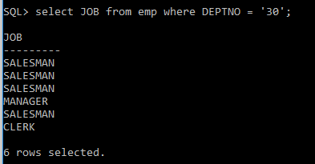

1. select dname as name, loc as location from dept where DEPTNO = '30';

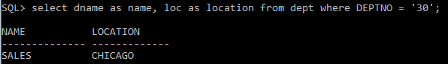

1. select ENAME "Name", DEPTNO "Department No" from emp where COMM > '0';

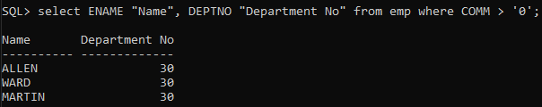

1. select ENAME "Name", DEPTNO "Department No" from emp where ENAME Like 'A%';

